**Ideation Phase**

**Define the Problem Statements**

|  |  |
| --- | --- |
| Team ID | PNT2022TMID53558 |
| Project Name | Project - Real-Time River Water Quality Monitoring and Control System |
| Maximum Marks | 2 Marks |

**Customer Problem Statement Template:**

**Example:**

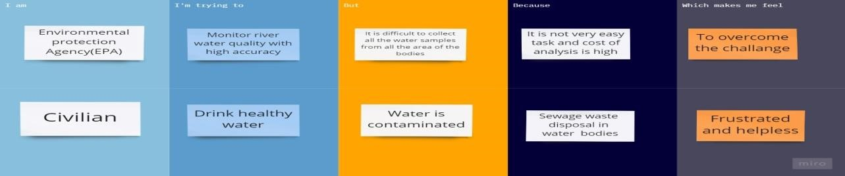

|  |  |  |  |  |  |
| --- | --- | --- | --- | --- | --- |
| **Problem**  **Statement (PS)** | **I am**  **(Customer)** | **I’m trying to** | **But** | **Because** | **Which makes me feel** |
| PS-1 | Civilian | Drink pure water | Water  consist of Low level minerals | Chemicals mixed in the river water | Uncomfortable |
| PS-2 | People | Know the drinking water quality from river. | It requires a product. | It’s physical and chemical properties doesn’t know | Satisfied. |
| PS-3 | People | Monitoring the river water characteristics. | I don’t have any device with automatic system. | Monitor it’s characteristics continuously. When the river water characteristics changed to notify me. | Safety about my health. |